Exercise 5 Specifying Relationships

Creating an association relationship in Rational Rose
- Click to select the association icon from the toolbar. The association icon may be added to the toolbar by right-clicking on the toolbar and selecting the Customize menu command
- Click on one of the associated classes in a class diagram.
- Drag the association line to the other associated class

The result as follows:

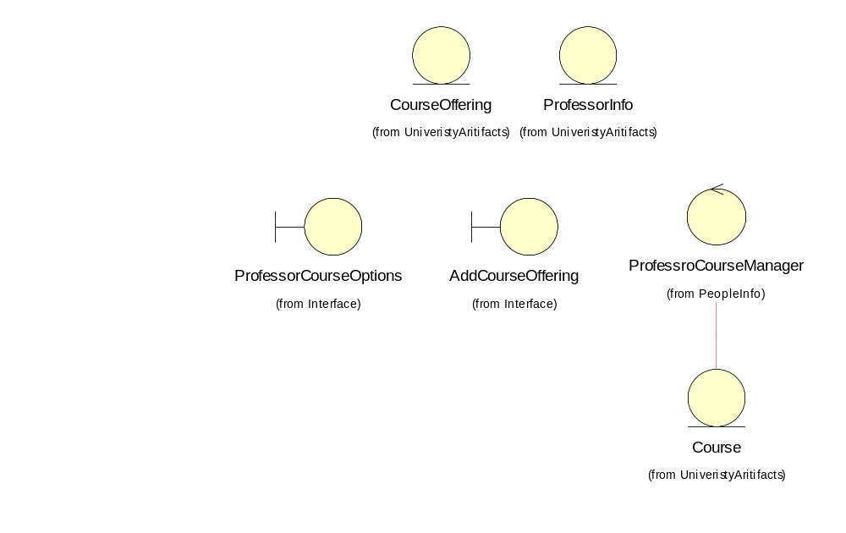

Creating an aggregation relationship in rational rose
- Select the Aggregation icon from the toolbar. The aggregation icon may be added to be added to the toolbar by right-clicking on the toolbar and selecting the customize menu command.
- Click on the class playing the role of the “Whole” in a class diagram and drag the aggregation line to the class playing the role of the “part”

An aggregation relationship is shown as follows:

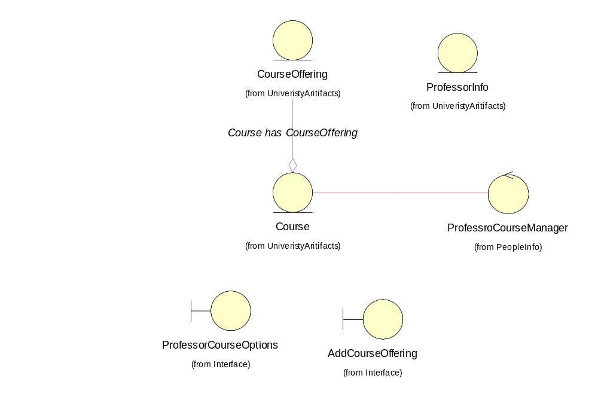

Naming Relationships in Rational Rose
- Click to select the relationship line on a class diagram
- Enter the name of the relationship.
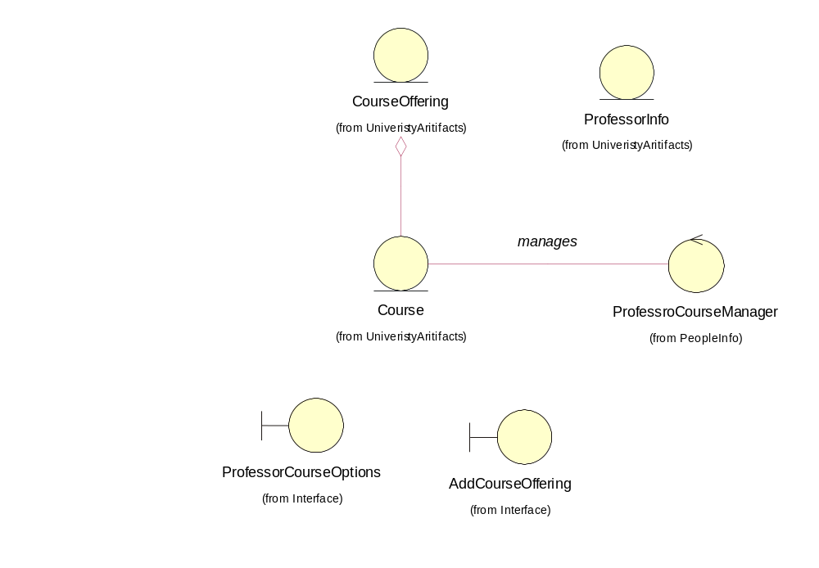

Creating Role Names in Rational Rose

- Right-click on the relationship line near the class that it modifies to make the shortcut menu visible
- Select the Role Name menu choice.
- Enter the name of the role.

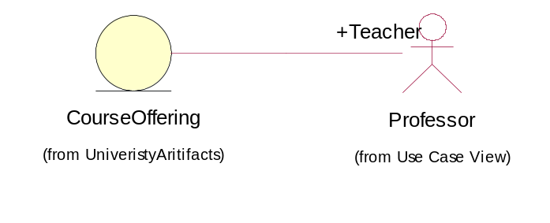
The Relationship is related in both directions
- A professor playing the role of the Teacher in both directions the CourseOffering
- A CourseOffering is related to a Professor playing to role of a Teacher.
Creating Multiplicity in Rational Rose
- Double-click on the relationship line to make the specification visible.
- Select the Detail tab for the role being modified (Role A Detail or Role B Detail)
- Enter the desired multiplicity.
- Click the OK button to close the Specification.

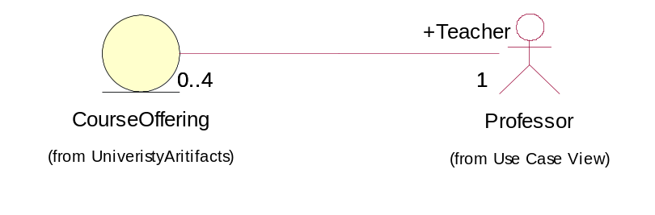

The drawing may be read in the following ways
- One CourseOffering object is related to exactly one professor object the role of the Teacher. For example, Math 101, Section 1 (a CourseOffering object ) is related to Professor Smith (a Professor object).
- One Professor object playing the role of the Teacher is related to zero to four CourseOffering objects. For example, Professor Smith (a Professor object ) is related to Math 101, Section 1; Algebra 200, Section 2, and Calculus 1, Section 3 (CourseOffering objects). Since the multiplicity is a range of zero to four, as few as zero CourseOffering objects to a maximum of four CourseOffering objects may be linked to one Professor object.

Creating a Reflexive relationship in Rational Rose
Multiple Objects belonging to the same class may have to communicate with one another. This is shown on the class diagram as a reflexive association or aggregation. Role names rather than association manes typically are used for reflexive relationships.
- Select the association (or Aggregation ) icon from the toolbar.
- Click on the class and drag the association(or aggregation) line outside the class.
- Release the mouse button.
- Click and drag the association(or aggregation )line back to the class.
- Enter the role name and multiplicity for each end of the reflexive association (or aggregation).

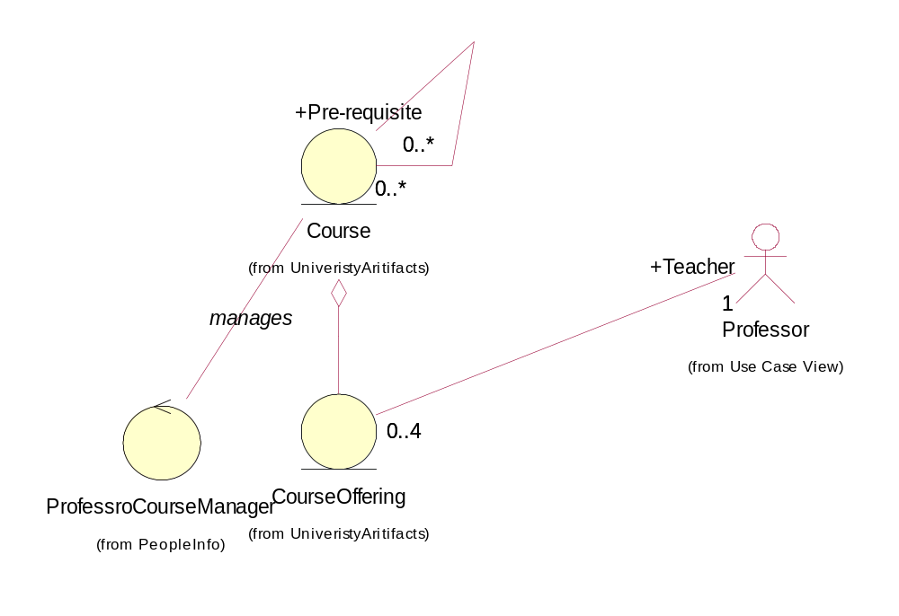
The reflexive relationship may be read in the following ways:
- One Course object playing the role of Prerequisite is related to zero or more course objects
- One Course object is related to zero or more Course objects playing the role of Prerequisite.
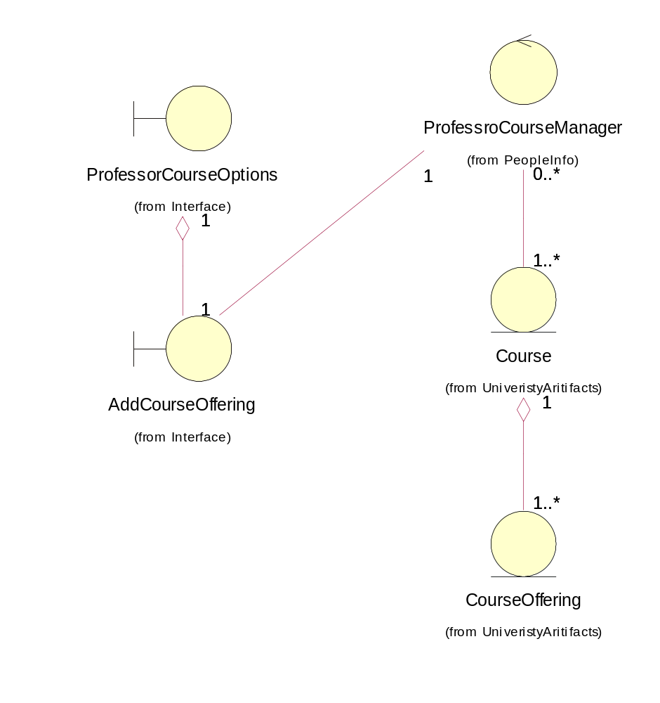
Creating Package Relationships in Rational Rose
- Select the dependency relationship icon from the toolbar.
- Click on the client package and drag the arrow to the supplier package.
